Work Voice Pay:
Work Voice Pay

CAMPAIGNING AROUND PAY

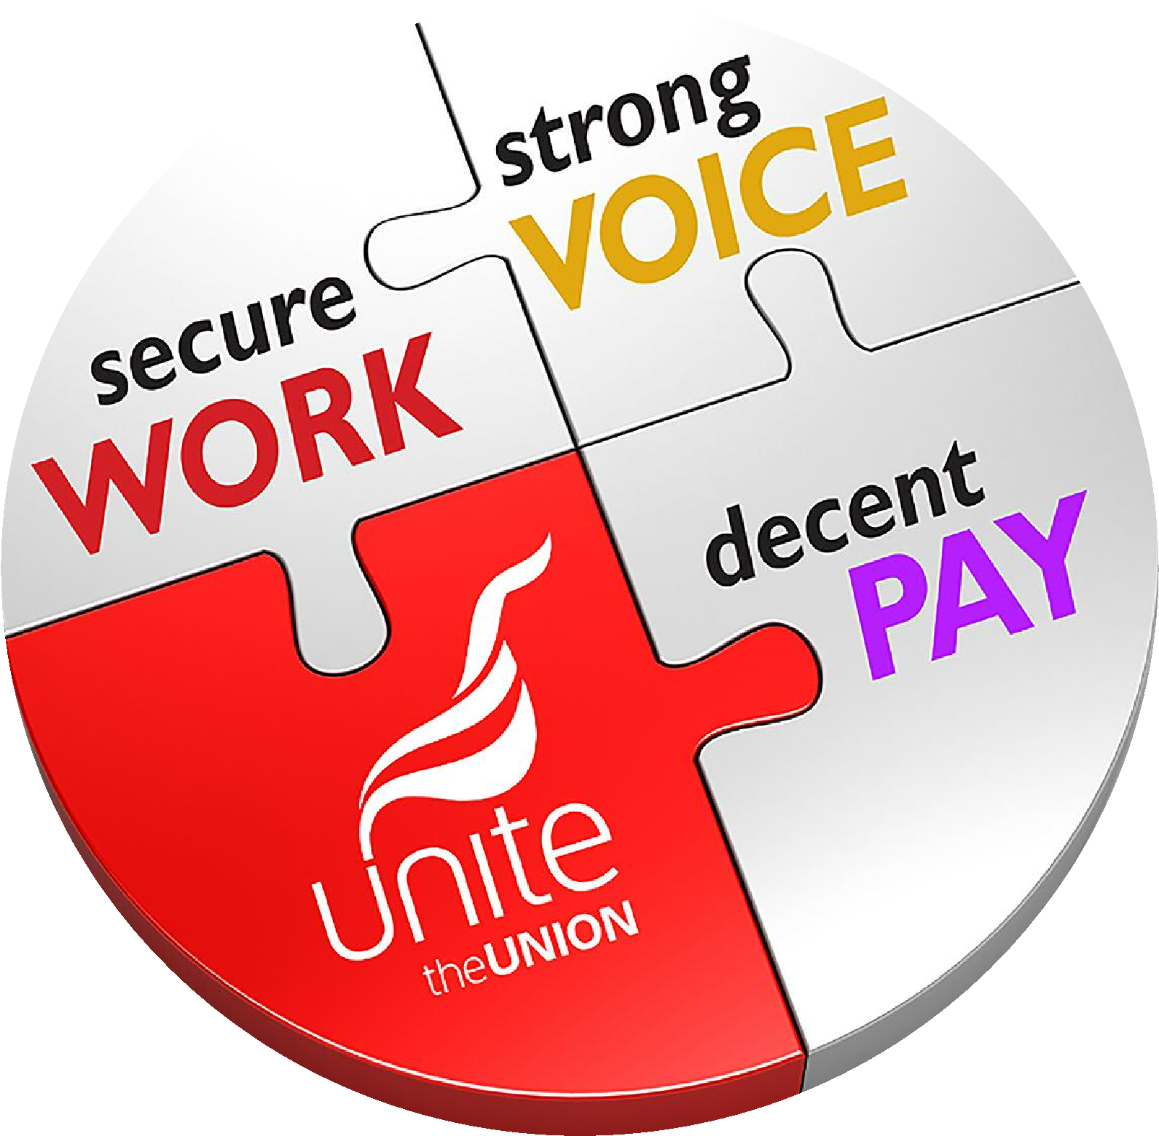

National Organising & Leverage Department
September 2022

Table of Contents

Why Your Pay Claim Campaign is Important | 4
Planning Your Campaign | 4
Campaign Aims | 4
Research | 5
The Plan | 6
Key Components of a Pay Campaign | 7
The Survey | 8
Pay Campaign Committee | 8
Demand Improved Union Facilities | 9
Distributing the Claim and Petitioning Support | 9
Regular Newsletters – Pay Bulletins | 9
Targeting Recruitment | 10
Badge/Sticker Days | 10
Using Digitial | 10
Using the Media | 11
Next Steps | 11
Recruit, Recruit, Recruit | 12
Useful Links | 13
Pictures | 13

Work Voice Pay

Work, Voice, Pay is the cornerstone of our Union’s industrial strategy. At Unite we know that it is only by delivering at the workplace that we remain relevant to working people. It is our success or failure at the bargaining table that we are ultimately judged on.

I am delighted that our research consistently proves that Unite negotiations secure better pay deals for working people. But we are determined to help further improve delivery for our members at the workplace. At its core this pledge focuses on what our Union does best:

- Securing good jobs and decent work
- Making sure workers have a strong and effective voice
- Getting decent pay and conditions

As part of this programme Unite is producing a range of Work, Voice, Pay templates and guides to assist you, our shop stewards and representatives, in your critical work on behalf of our members. I hope that this latest guide to campaigning on pay will help you grow the union and win for workers.

Sharon Graham
General Secretary

Why Your Pay Claim Campaign is Important

The annual pay round provides an ideal opportunity to grow strength in the workplace.

The aim should not be simply to achieve a decent pay increase but also to achieve membership growth, to increase Unite’s profile, and involvement of members, develop leadership and improve our facilities.

Work, Voice, Pay intends to ensure that everywhere Unite has recognition there is a proper pay claim campaign. This guide is intended to help run such a campaign.

Planning your campaign

Shared aims and commitment to a common plan are essential to the success of any workplace campaign.

Campaign aims:
- Improved pay and conditions
- Increased membership – how many new members: from which work areas?
- Increased involvement – what collective actions can you plan? How many workers can you get involved in each? NB It is essential to map participation in these actions to target recruitment and monitor success
- Develop leadership – where do you need new reps and helpers?
- Improved facilities – what do you need in terms of increased release, Shop Stewards/Reps complement, members’ meetings etc?
- Increased profile – through what media?

Research

The first step is to research the company. You need to do this to:
- Make your case as effectively as you can
- Understand your strengths and weaknesses and those of the company
- Prepare for any potential escalation – every pay campaign has the potential to become a dispute and once that arises you will be confronting an employer that is, by definition, hostile. Your aim in any dispute is simply to win
- Anticipate management tactics

Ask questions, including:
- What does your mapping tell you about where you need to concentrate your work?
- Where you are most able to apply pressure on the company – for example, is there a work area that can disrupt the operation and where you are strong?
- Who do you need to persuade? What are your key messages?
TOP TIP

Have a plan

In 100% planning and training sessions we split the plan into four themes:

- Growing membership
- Strengthening shop stewards
- Winning on the issue: and
- Improving communications

It may help to use the same strands in your pay plan.

Your targets should be SMART:

- Specific
- Measurable
- Attainable
- Relevant
- Timebound

- Research inflation stats (RPI) and company financial performance – profit, directors’ pay, dividends etc.
- Who is on the board? – plan to lobby them if the pay campaign goes beyond normal negotiations
- Who are the company’s investors – can you take the campaign to them if need be?
- Who are the key clients and can they also be lobbied if need be?
- Where might they bring in labour from to break any dispute and how do you stop that?
- What else could help effectively disrupt the operation or pressure the company?

The Plan

Here is an example for a few weeks:

 | Weeks 1 & 2 | Weeks 3 & 4 | Weeks 5-8
Build membership | Survey workforce. Ask non-members to take part in a survey and invite to join.  Aim: 25 new members from names identified by reps | Activists and reps asking non- members who completed the survey to sign petition and join Unite the Union.  Aim: 20 new  members and 50% to have signed the petition | Recruitment drive from the first meeting with the company – shift meetings, targeted 1 to 1 recruitment, phone bank to ask people to join.  Aim: 50% of non- members who have signed the petition or worn a badge to join
Strengthen Stewards | Start pay campaign committee meetings. Reps to invite 4 named activists to get involved. Task them to get in 10 surveys each.  Include a demand for 8 hours a week more facility time or for a new steward for nights in the pay claim | Ask new activists to take a new newsletter around and to ID 2 non- members they know who completed the survey to ask them to join.  Ensure we now have a rep or an activist in every work area | New activists can do a lot of the recruitment.  ID candidates for new Shop Steward/Rep position and elect them after the pay campaign has finished
Win issue | Activity & growth will strengthen our bargaining position. Research:  company performance,  Directors’ pay,  Inflation stats (RPI) etc | Complete the pay claim using the survey.  Collect a petition in support of the pay claim to show strength of feeling.  Aim: 65% of the workforce signing and map who signs.  Submit the pay claim to the company and meet on a set date | All wear a Unite badge on the day of second meeting between reps and company to discuss pay.  Reps and activists to distribute and ensure being worn. Mark against map  Aim: for at least 65% to participate.  Hold a workplace ballot on the final offer – ask non- members to join and vote today.  Aim: another 15 new members
Improve Communications | Use posters and a newsletter to launch pay survey | Report back on the survey with a newsletter – include states on inflation etc. Distribute the items of the pay claim and ask workers to support it with a petition as above | Send a second newsletter to highlight company profits, CEO pay etc.  Text all contacts about the pay vote.  Circulate the claim on the day of negotiations

Some key components of a pay campaign

- Survey
- The claim
- Pay campaign committee
- Demands for improved facilities
- Distributing the claim and petitioning support
- Petition support
- Regular newsletters – pay bulletins Targeting recruitment
- Other collective actions
TOP TIP

Using your mapping
Map who competes surveys, attends meetings, signs petitions etc. Use this to plan who will speak to whom about joining an action. Identify individuals who have taken part in an action to ask them to join or get more involved.

The Survey

- Find out more about what people are concerned about, including:

- Shift allowances
- Sick pay
- Other basic campaigning ideas
TOP TIP
Make sure you are ‘ballot- ready’

Use surveys, meeting attendance sheets and petitions to help check you have all your members’ details up-to-date.

- Test strength of feeling

- Check individual details and gather contact info:

- Member?
- Interested in joining / getting more involved?
- Work area
- Mobile/ email

- This shows that we listen

- Start a conversation – engage colleagues with the union

- This raises the profile of Unite

- It informs our communications e.g. 86% have had money difficulties in the last year

- This can help educate our members; and
- It strengthens our argument in negotiations

- This reinforces the message that it is ‘their’ pay claim – they own it, they help shape it and they need to campaign for it

Pay Campaign Committee

- Many workers can be intimidated by being asked to be a Shop Steward/Rep but attending a meeting and helping the pay campaign can be less daunting
- A campaign committee helps spread the work and lightens the burden on reps
- It helps to drive the campaign
TOP TIP

Make sure you are ‘ballot-ready’
Use surveys, meeting attendance sheets and petition to help check you have all your members’ details up-to-date.

- Give reps and activists from these meetings simple, quantifiable tasks – take the newsletter to line three; talk to Ali and Sarah about joining up
- Make sure the committee meets regularly
- Hold open meetings too. Invite non-members and use these as opportunities to recruit

Demand Improved Union Facilities
- The pay round is the ideal time to seek to improve the facilities that Shop Stewards/Reps have to perform their union duties
- If we ask workers to support a demand for improved facilities in the survey it will be seen as coming from the workforce and can’t be dismissed as Unite Shop Stewards/Reps wanting some time off

Distributing the Claim and Petitioning Support
- The claim raises Unite’s profile in the workplace
- Including survey results shows that Unite listens to workers – “from the survey, you said x, y & z. This is the basis of our claim”
- It reinforces message that it is the workers’ pay claim
- It tells management that the workforce is united behind the reps and the claim
- This is an opportunity to talk to the workforce and to ask them to join
- Shows of hands, wearing stickers etc are other ways of showing support

Regular Newsletters – Pay Bulletins
- Newsletter and bulletins help to keep the workforce informed and motivated through what can be a lengthy process
- This raises the profile of the union
- It helps you make your arguments to the workforce and the employer
- These good, simple tasks allow new activists to help and get involved

Targeting Recruitment
- Rather than simply asking activists to recruit five members:
- Sit down with mapping and ID who they know and can ask to join, or
- Identify non-members that have signed a petition and can be asked to join you and help with the campaign for fair pay
- If given a specific task like this it is much better to debrief e.g. “Debbie joined, John not in this week, Samina not sure but we are talking again next week…” as it tells us a lot more than, “well I asked lots of people but only one joined”. It is also easier to give meaningful praise and direction if you can congratulate someone on getting in a new member. Consider rehearsing how activists can improve the message with people next time etc.
- Hold a collective sign-up – ask named workers to join up en- masse in the run-up to the negotiation – use face to face approaches by reps and activists, open meetings, phone banking, gate visits etc.

Badge/Sticker Days
- They raise Unite’s profile
- This encourages involvement and further identification with Unite the Union. Non-members who wear a badge have shown that they share some of the aims of Unite. This should lead to them joining if they are approached in the correct manner
- It shows the unity of the workforce very visually to management

Using Digital

Most workers now use email, the internet and social media platforms such as Facebook. Companies and journalists will have twitter accounts that they monitor. Unite’s Organising and Leverage Department has invested in a package to support direct emailing and petitioning that can track involvement and pressure companies.

There are a range of electronic tools you can use including:

- Surveys – put your survey online, email everyone asking them to complete and track those that do – you can use Google Forms for this: https://docs.google.com/forms/
- Online petitions e.g. change.org / ipetitions.com / petitionbuzz.com
- Email the company
- Use Facebook to get your message across
- Twitter – can be particularly effective for talking to politicians, journalists and companies. Most companies will have a Twitter account, and they will monitor it. ‘Handling’ i.e. naming a company in tweets can alert them to a campaign and pressure the company.

It is important to be careful when using these tools – respect people’s data rights and just as with a poster or press release, be factual and consider the tone of what you put out: Can you prove it is true? Do you have permission to use these emails? Does it move the campaign? Are you confident it will not have a negative impact? If your answer to any of these questions is no, think again.

Using the Media
- This can help tell your story, pressure a company, popularise the union
- Consider trade press, online and broadcast as well as the local paper

Next steps

- The members will have a chance to vote and will either celebrate a pay rise win or reject it and campaign further for improvement.

- Agree a workplace ballot so the reps can explain the offer and invite people to join and have their say – support them if necessary
- Use the workplace ballot to raise Unite’s profile and increase membership
- If members vote to reject it is essential to plan thoroughly with reps and activists the preparation of an industrial action ballot, building support for action and deciding how to lever the company to improve its offer:

When planning the ballot and industrial action campaign with the Shop Stewards/Reps consider the following:

- How can we stop the operation?
- How can we build solidarity from other bases and companies?
- What is the most effective pattern of action?
- How are we going to build support? Group meetings, one to one, email, texting etc.
- How do we ensure we will get the vote out? Collect pledge slips; phone bank; record voting intentions; show support with a lapel sticker etc.
- What is the media strategy?
- What is our internal communication strategy?
- What messages and tactics will the company use and how do we counter them?

Recruit, Recruit, Recruit

Every worker cares about their pay. This is what the union does best – campaigns collectively to improve pay. At every stage, ask workers to join Unite:
- Thanks for helping with the survey, will you help the campaign by joining us today?
- You have signed the petition, that’s great, if you want to win fair pay, we need your involvement. Every new member helps show the company we are united for fair pay. Will you join today?
- Now is your chance to join and have a vote. Can I sign you up today?

Useful Links

Worksmart – Website from TUC that is useful for finding information on the performance of your company:
https://worksmart.org.uk/

Companies House – for free Company Annual Reports and Accounts: www.companieshouse.gov.uk/

The Unite Research Department “Bargaining Brief”:
www.unitetheunion.org/campaigning/repszone/bargainingbrief/

Labour Research Department (LRD) Pay and Conditions Database:
www.lrd.org.uk/payline/index.php
Username: unite
Password: opal961

Retail Prices Index – lists current and past inflation figures:
www.ons.gov.uk/ons/taxonomy/index.html?nscl=Retail+Prices+Index

Pictures

These can really help increase the impact of your newsletter. Just typing something like ‘pay rise cartoon’ into Google Images will often give you some excellent images. https://www.google.com/imghp
TOP TIP

Know your company
You can learn a lot by Googling your company directors’ names, checking Wikipedia, and by searching the ‘corporate’ website of your company. Sometimes this is a section of their main website, sometimes it is a separate site. Search for ‘your company corporate’ and you should find it.

You may also try:
http://www.cartoonwork.com/

Unite can help with examples of pay campaigning documents. Please visit the Unite website where you will find:

- A Pay Bulletin (EasyJet)
- A Pay Survey (GKN)
- A Pay Claim (ICTS)
- Campaign Materials A Pay Petition

