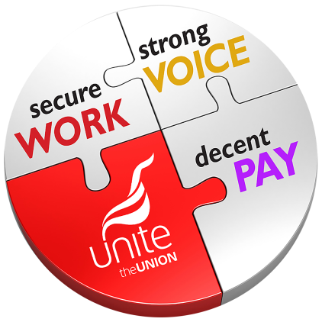
Company X Pay Petition
We the undersigned support our pay claim for 2022. We believe this is a fair and reasonable claim and we urge the company to listen to the case made by our Unite the Union reps for a fair deal on pay.
Name | Work Area | Mobile |  |  |  |  |  |  |  |  |  |  | Email |  |  |  |  |  |  |  |  |  |  |  |  |  |  |  |  |  | Signature | Unite member? | Keep in touch email* | Keep in touch phone*
* I consent to being kept in touch about Unite the Union and this campaign by phone / email.
This petition and your personal details will be kept confidential by Unite the Union. The petition will be submitted to [whoever petition is submitted to] only and will be retained by Unite for the duration of the [name of campaign] campaign and any associated issues. Unite the Union’s full up-to-date privacy policy can be found at www.unitetheunion.org/privacypolicy

